The Girl Scout Law
I will do my best to be:
You will find me under the leader’s chair,
I cannot tell a lie,
Take only one, so you can share,

And then you too will be ________________________ and ________________.
We caper do to Kapers
So that we can lend a hand,
We choose a job that’s special

So that we will be ________________________ and ________________.
Fathers and mothers,
sisters and brothers,
At the door show this with hugs they are sharing.
We hug them back

To be ________________________ and ________________.
Look out the window and you will see
A lion fearless as a Brownie
We have performed for many a throng,
And we did lift up our voices in song,

Proving that we are ________________________ and ________________.
I say what I mean and I mean what I say,
For I know that it is true,
When I look in the mirror I will see

That I am ______________________________________________.
When we take turns with one another
And listen quietly to our mothers,
When in the kitchen we eat healthy
And then exercise with our brothers,
I and we each separately

Show that I __________________________________________.
We stand at attention and salute
To do this properly
For police, soldiers, and flags

To show that we __________________________________________________.
Water, water, everywhere, but
Where do we go to drink?
WOW taught us ways to save it nicely

So now we __________________________________________________.
We clean up when we are all done
And then we’ll Leave No Trace,
We recycle trash in the blue one,

So we can __________________________________________________.
Now that we are almost done,
We’ll give a great big shout,
In our circle you’ll find the last one

Now we can __________________________________________________!

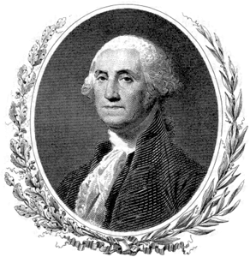

honest and fair | honest and fair | honest and fair | honest and fair
honest and fair | honest and fair | honest and fair | honest and fair
friendly and helpful | friendly and helpful | friendly and helpful | friendly and helpful
friendly and helpful | friendly and helpful | friendly and helpful | friendly and helpful

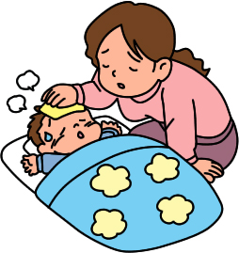
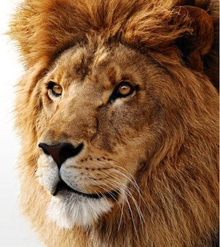

considerate and caring | considerate and caring | considerate and caring | considerate and caring
considerate and caring | considerate and caring | considerate and caring | considerate and caring
courageous and strong | courageous and strong | courageous and strong | courageous and strong
courageous and strong | courageous and strong | courageous and strong | courageous and strong

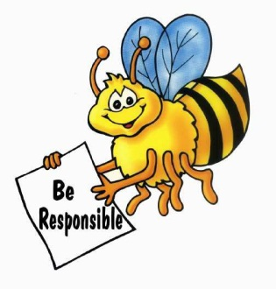

responsible for what  I say and do | responsible for what  I say and do | responsible for what  I say and do | responsible for what  I say and do
responsible for what  I say and do | responsible for what  I say and do | responsible for what  I say and do | responsible for what  I say and do
respect myself and others | respect myself and others | respect myself and others | respect myself and others
respect myself and others | respect myself and others | respect myself and others | respect myself and others

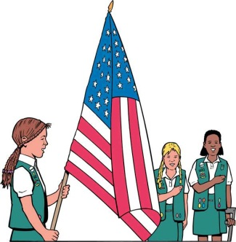

respect authority | respect authority | respect authority | respect authority
respect authority | respect authority | respect authority | respect authority
use resources wisely | use resources wisely | use resources wisely | use resources wisely
use resources wisely | use resources wisely | use resources wisely | use resources wisely

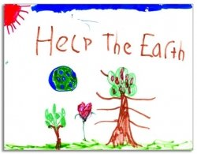

make the world  a better place | make the world  a better place | make the world  a better place | make the world  a better place
make the world  a better place | make the world  a better place | make the world  a better place | make the world  a better place
be a sister to  every Girl Scout | be a sister to  every Girl Scout | be a sister to  every Girl Scout | be a sister to  every Girl Scout
be a sister to  every Girl Scout | be a sister to  every Girl Scout | be a sister to  every Girl Scout | be a sister to  every Girl Scout

What to do
- Print first two pages – one for each scout
- Print pages 3-12 double-sided (so the words end up on the back of the correct pictures), enough for one picture for each girl. Cut apart into ‘cards’.
- Hide in the places indicated in the table below.
- Once the girls find them, they can write the words on the blanks in their form and glue the pictures in the empty squares next to the appropriate rhyme.
KEY
You will find me under the leader’s chair,  I cannot tell a lie,  Take only one, so you can share,  And then you too will be ________________________ and ________________. | Under the Leader’s chair  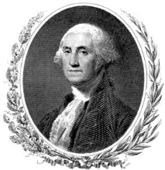
We caper do to Kapers  So that we can lend a hand,  We choose a job that’s special  So that we will be ________________________ and ________________. | With the Kaper chart
Fathers and mothers,  sisters and brothers,  At the door show this with hugs they are sharing.  We hug them back  To be ________________________ and ________________. | At the door  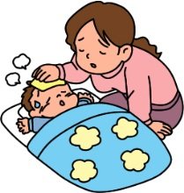
Look out the window and you will see  A lion fearless as a Brownie  We have performed for many a throng,  And we did lift up our voices in song,  Proving that we are ________________________ and ________________. | At the window  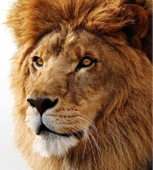
I say what I mean and I mean what I say,  For I know that it is true,  When I look in the mirror I will see  That I am ______________________________________________. | At the bathroom mirror  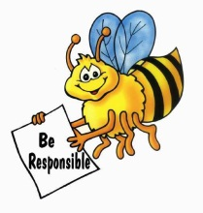
When we take turns with one another  And listen quietly to our mothers,  When in the kitchen we eat healthy  And then exercise with our brothers,  I and we each separately  Show that I __________________________________________. | In the kitchen
We stand at attention and salute  To do this properly  For police, soldiers, and flags  To show that we __________________________________________________. | Under the flag
Water, water, everywhere, but  Where do we go to drink?  WOW taught us ways to save it nicely  So now we __________________________________________________. | At the water fountain or sink
We clean up when we are all done  And then we’ll Leave No Trace,  We recycle trash in the blue one,  So we can __________________________________________________. | Near the recycling bin
Now that we are almost done,  We’ll give a great big shout,  In our circle you’ll find the last one  Now we can __________________________________________________! | In the Brownie circle

