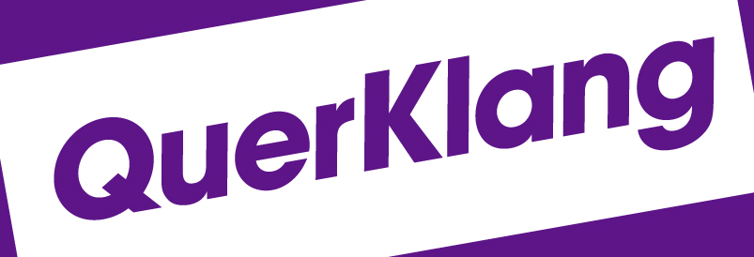

LETTER OF INTENT FOR QuerKlang EUROPE
Between
Kulturkontakte e.V.
And

(INSERT NAME OF INSTITUTION / PERSON)

In line with the development of friendly international cooperation in accordance with our mutual interests in developing programs of musical education and exchanges and for the purpose of establishing a long-term mutually beneficial association for the project QuerKlang, Kulturkontakte e.V. and (NAME OF INSTITUTION / PERSON, COUNTRY) join in the following letter of intent.

Both Kulturkontakte e.V. and (NAME OF INSTITUTION / PERSON) are committed to working together to develop specific music educational processes and mutual concerts throughout the years 2015 – 2017. Our agreements will provide logistical and management details appropriate to the successful operation of the project. These agreements will fulfill the spirit and purpose of this general letter of intent.

Signatories

(NAME OF INSTITUTION) Kulturkontakte e.V.

_____________________________ ____________________________
(NAME) Date Kerstin Wiehe Berlin,10.02.2014 (FUNCTION) Overall Project Coordination
(TITLE) (M.A.)

